**Project 6:**

**Working with IAM Roles with S3 and bootstrapping with EC2**

**Task 1: Creating a bootstrapped instance**

Step 1: Create a Linux Instance with bootstrap code.

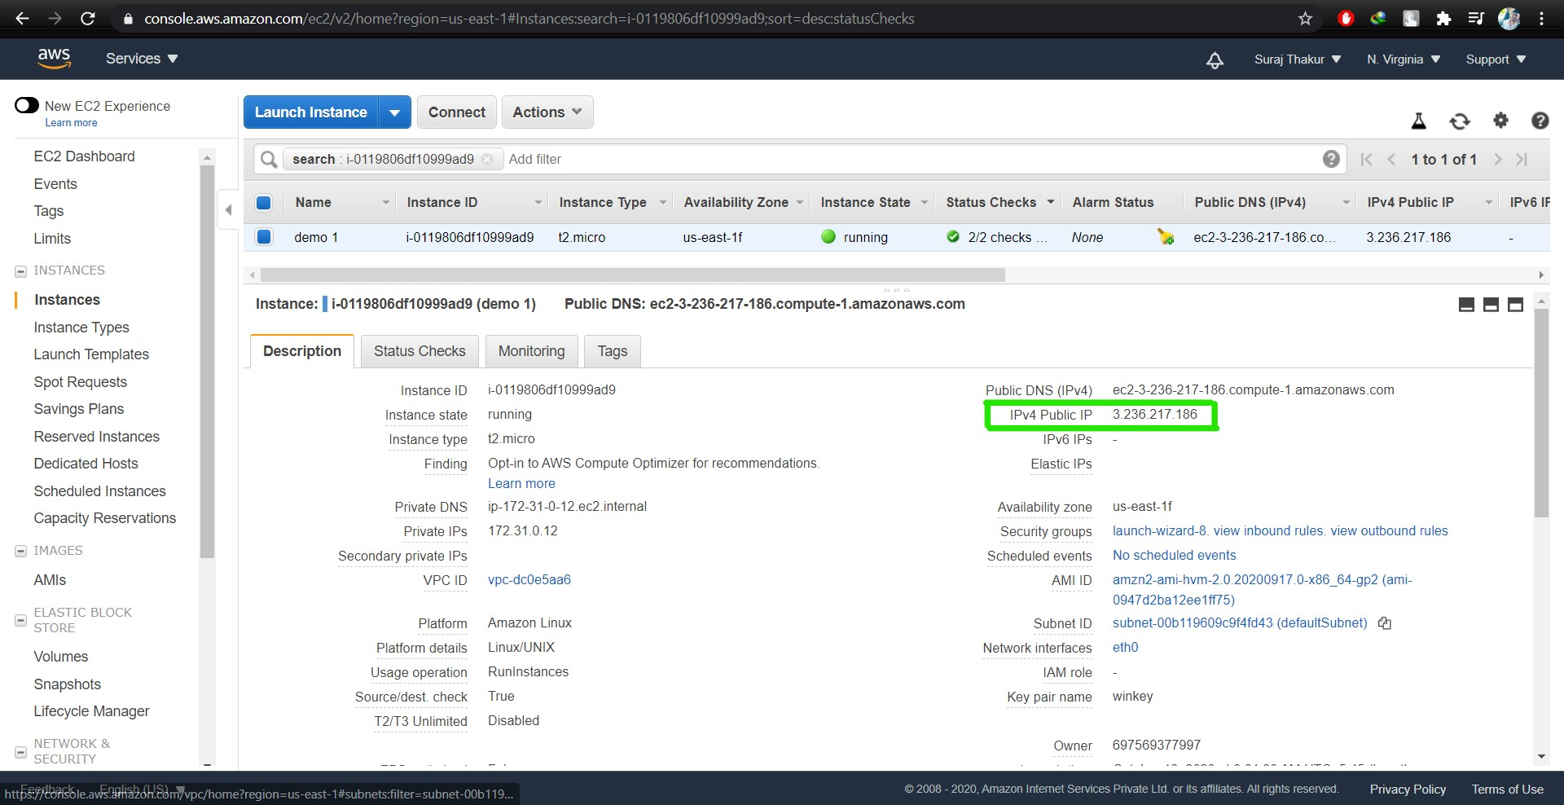

Step 2: Check the user data of the bootstrapped instance

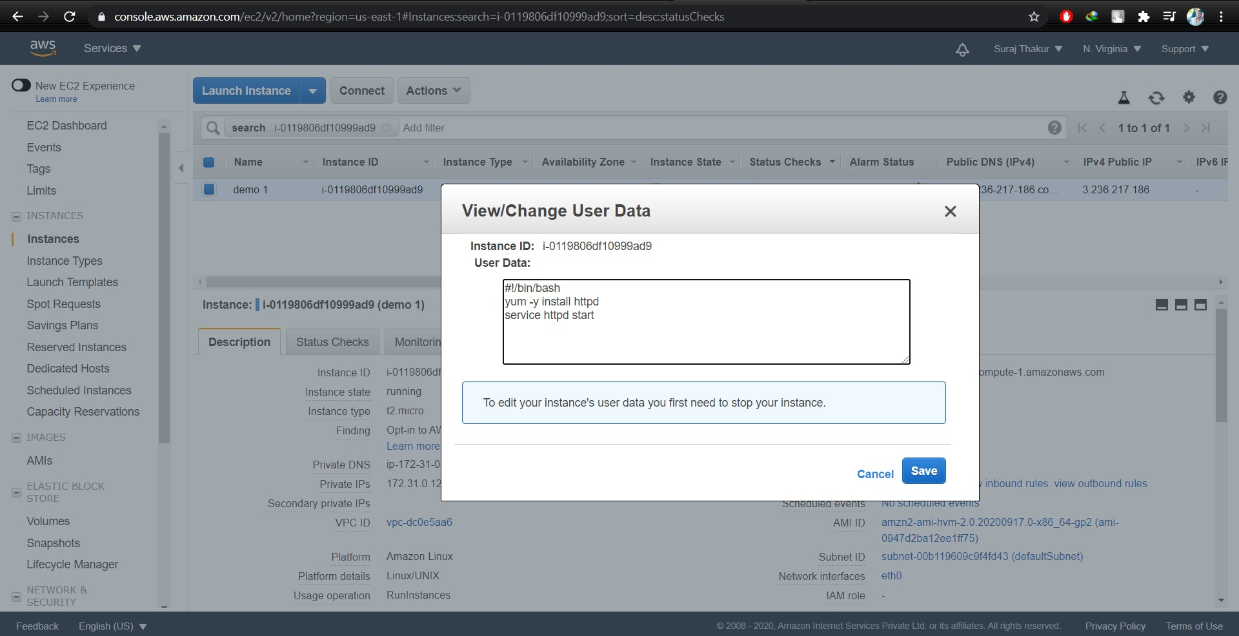

Step 3: Copy and paste the Public IP address of the instance. If the bootstrap code is correct then it will display Test page of Apache HTTP server.

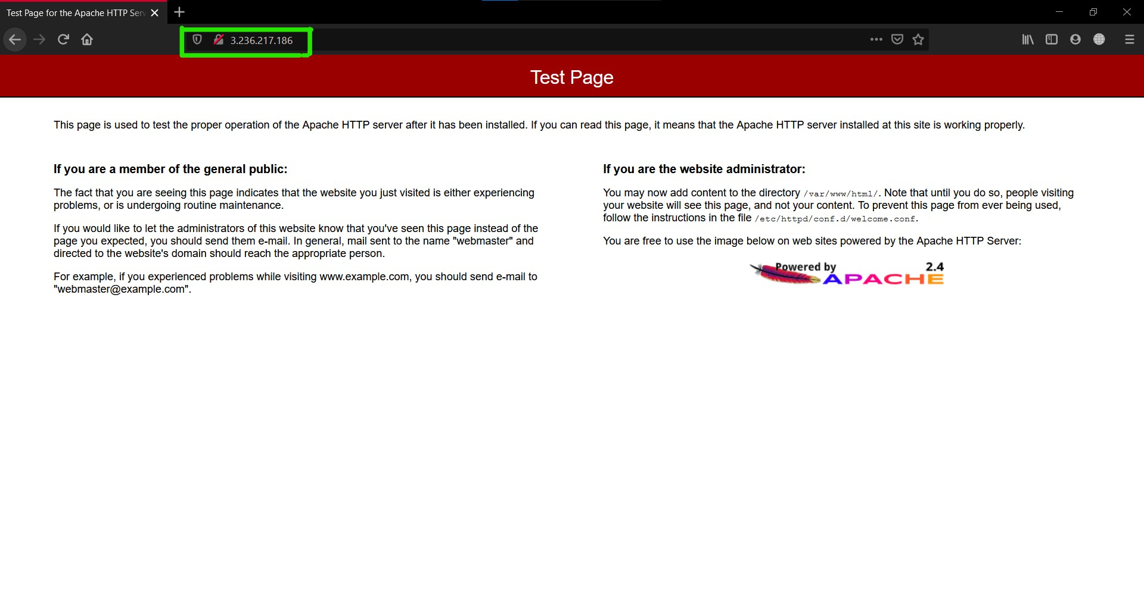

**Task 2: Checking bucket list and creating a new bucket from EC2 using IAM Roles**

Step 1: Create a bootstrapped instance

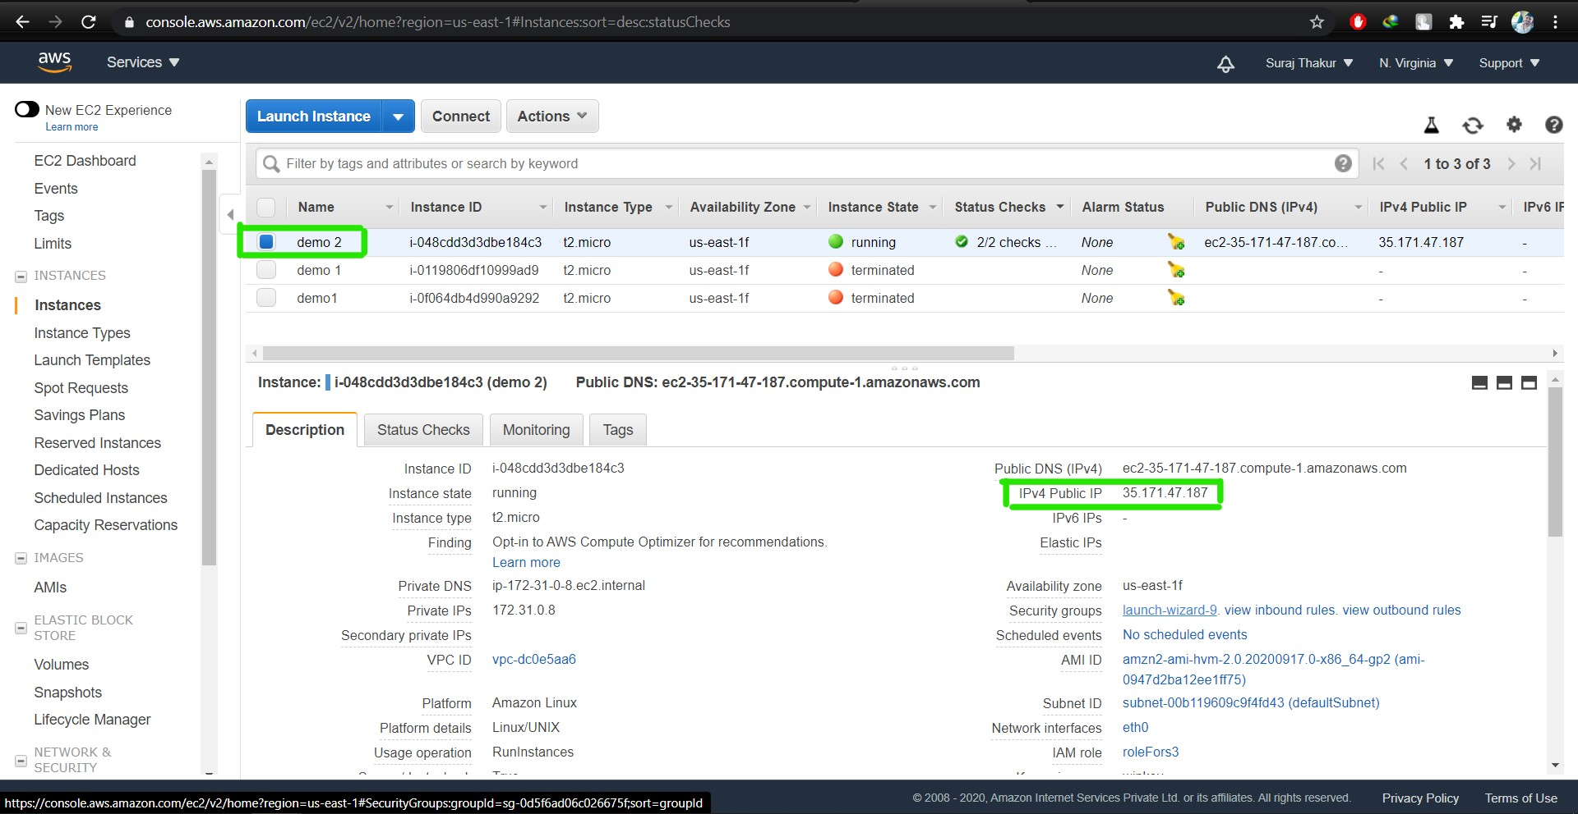

Step 2: Create an IAM for S3 bucket

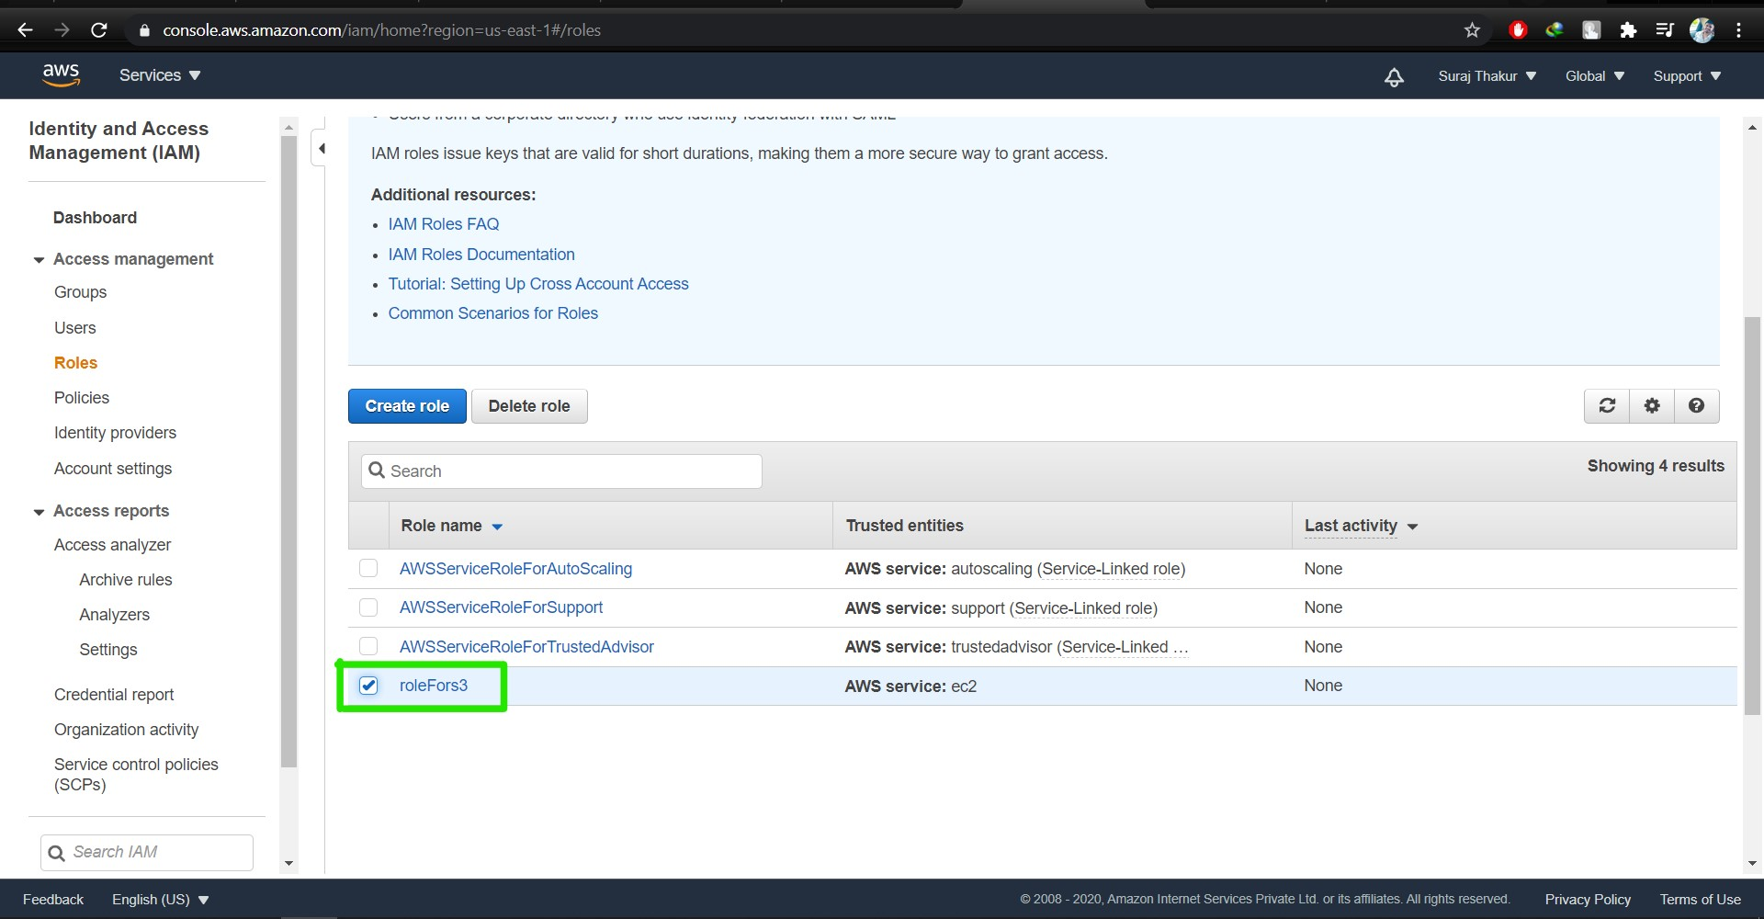

Step 3: Create S3 bucket using console

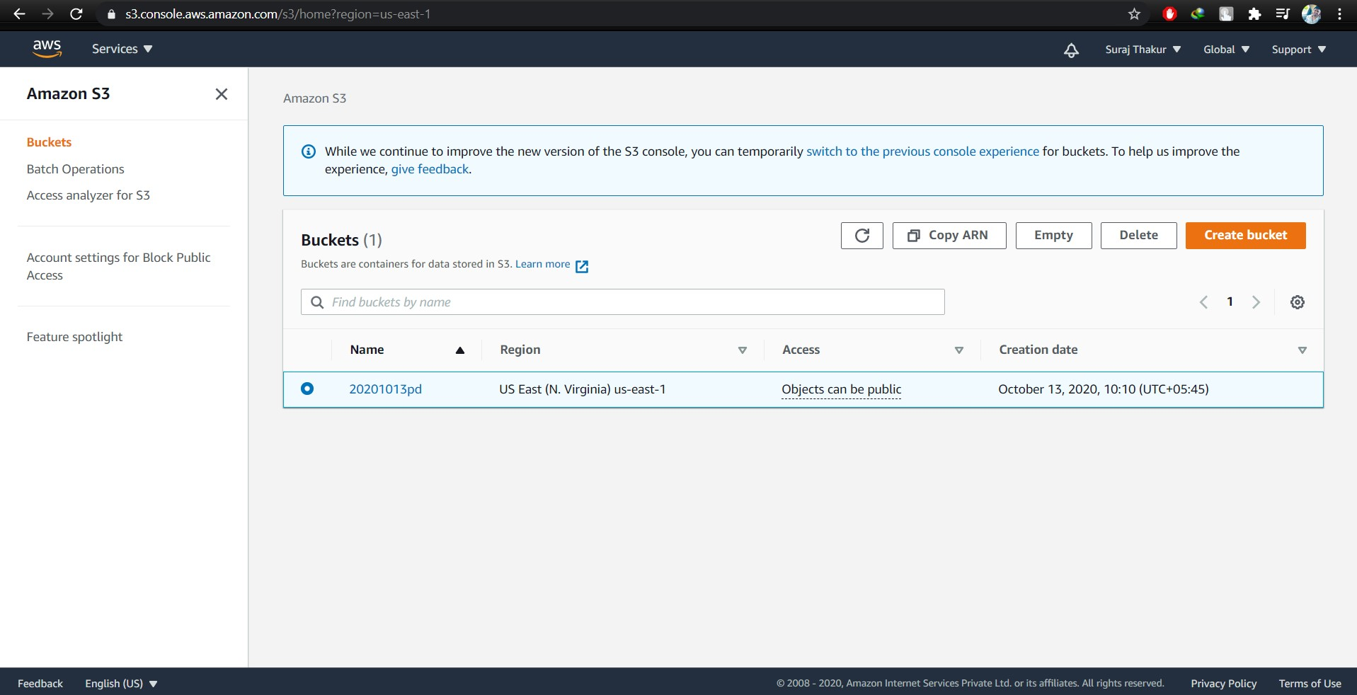

Step 4: Use command for viewing S3 bucket that exist :  
**aws s3 ls**

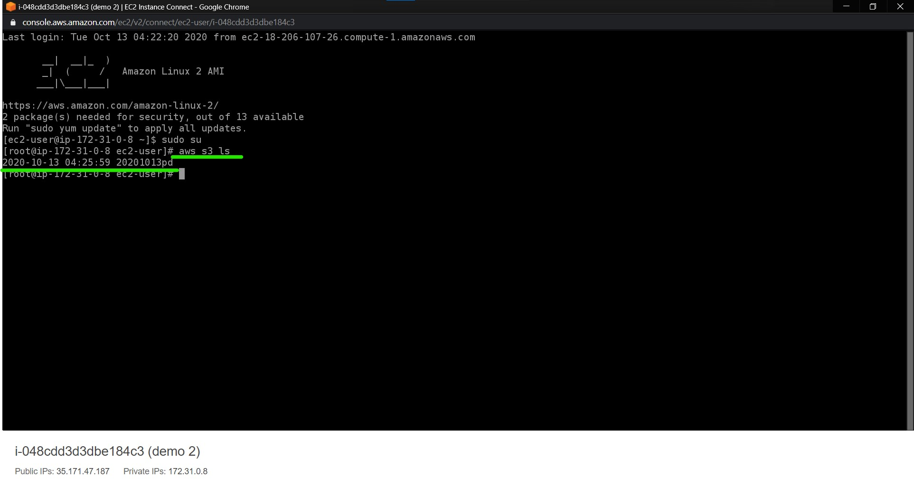

Step 5: Use command for creating new s3 bucket using CLI:

**aws s3 mb s3://(bucketname) (This cmd is used to create a new bucket, mb means make bucket, letsupgrade02 is the new bucket name)**

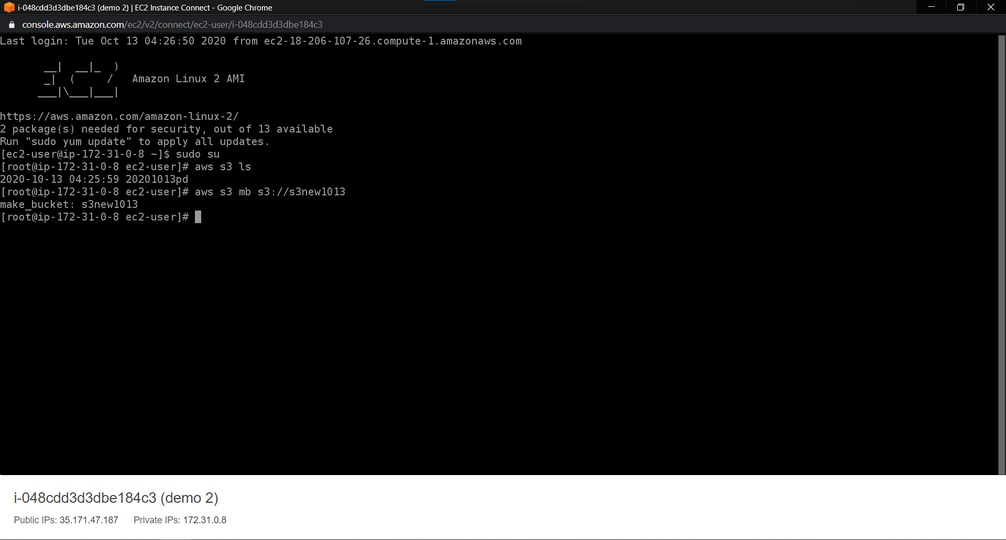

The newly created s3 bucket using CLI:

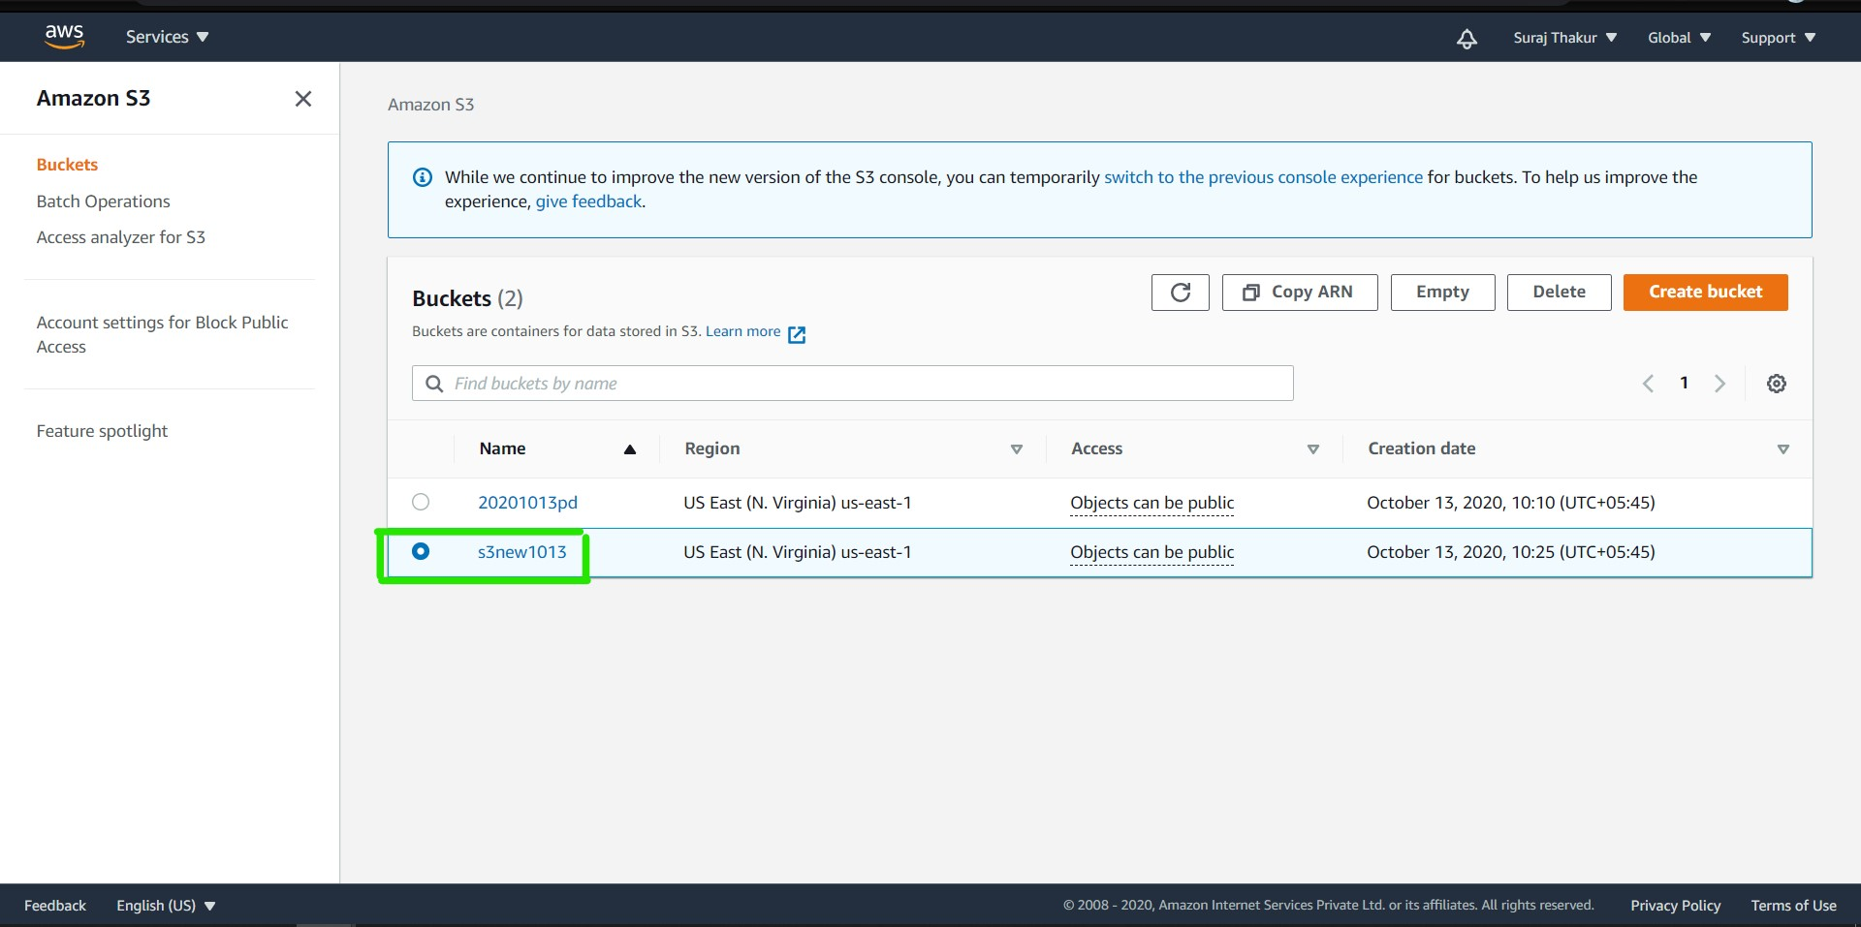

**Task 3: Hosting a webpage using the bootstrap script on ec2**.

Step 1: Create a S3 bucket

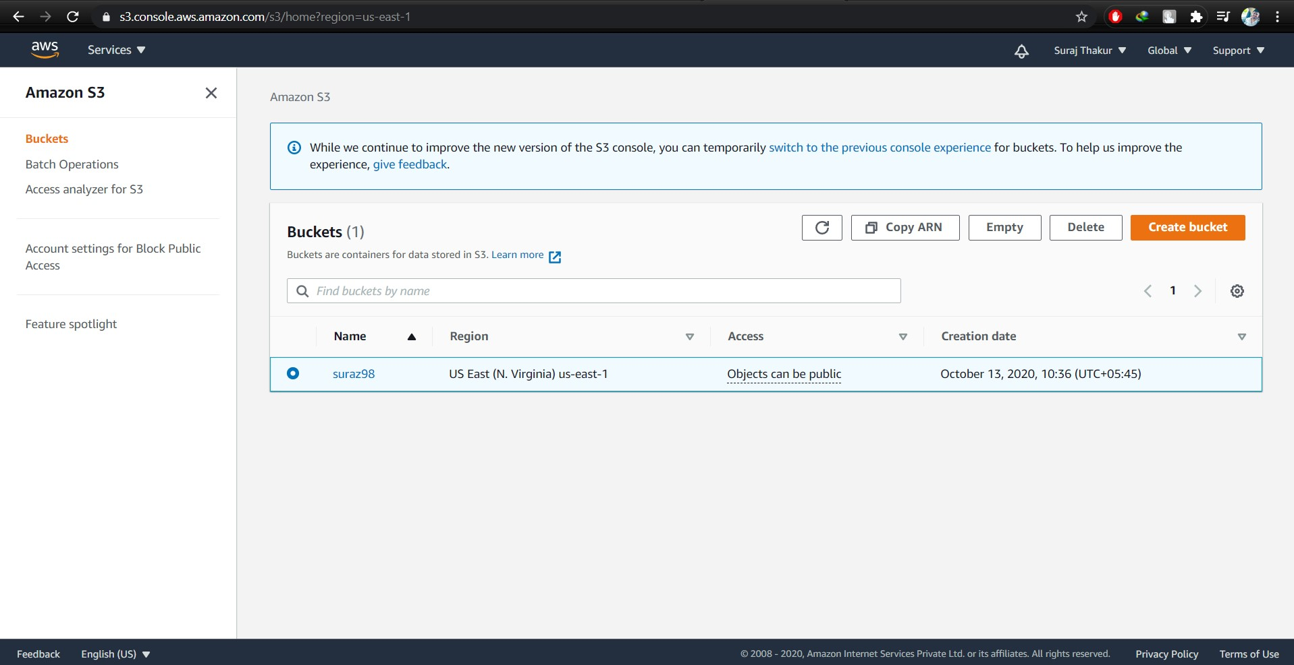

Step 2: Insert a file; index.html inside the bucket

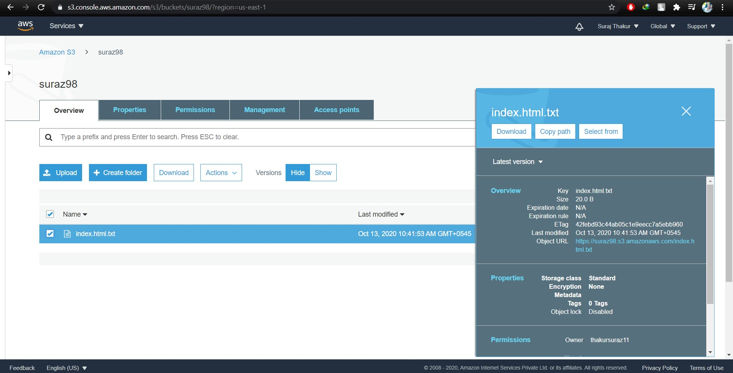

Step 3: Check the user data of the bootstrapped instance

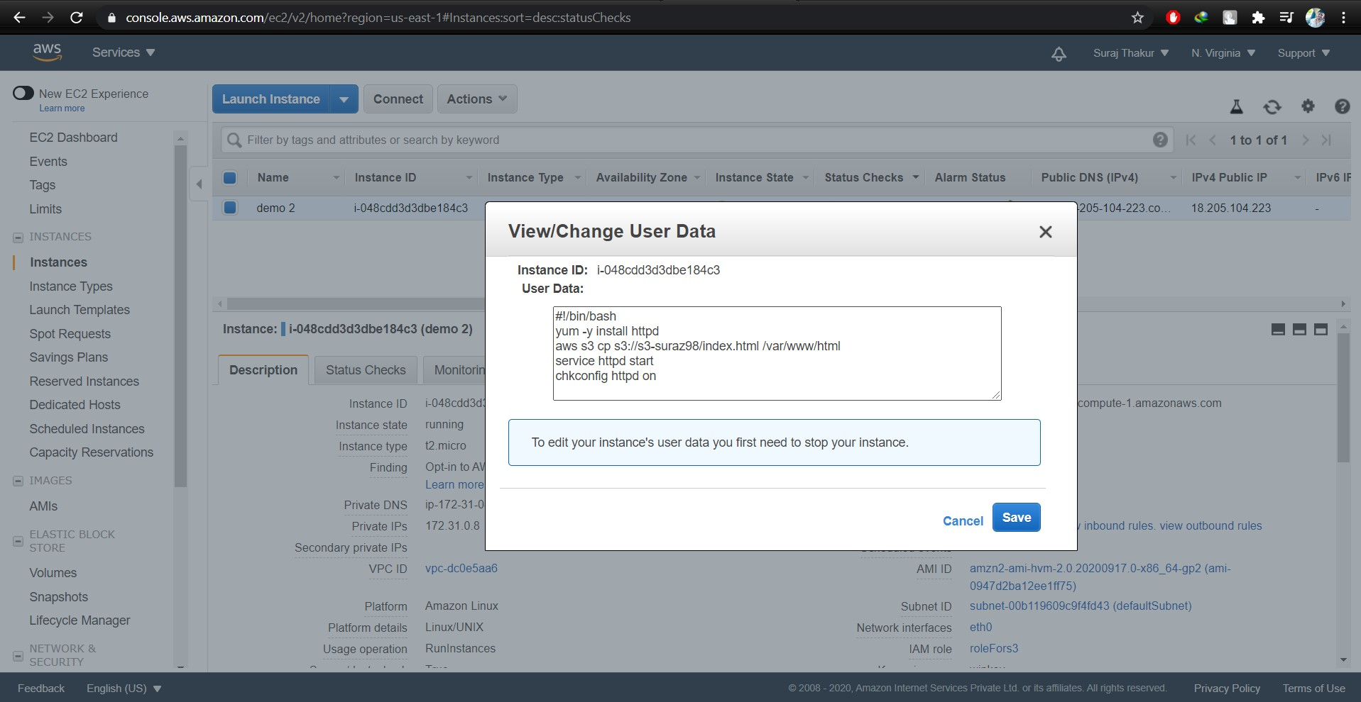

Step 4: Copy the URL link of the index.html file and paste it in the browser which will show the web page that has been created.

